How to access your personal information

(Wage and Earning, W2, Current YTD Totals etc.):

Visit www.onalaskaisd.net and click on the Human Resources section.

At the bottom of this page click on this link: 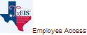

You will be taken to a page that looks like this:
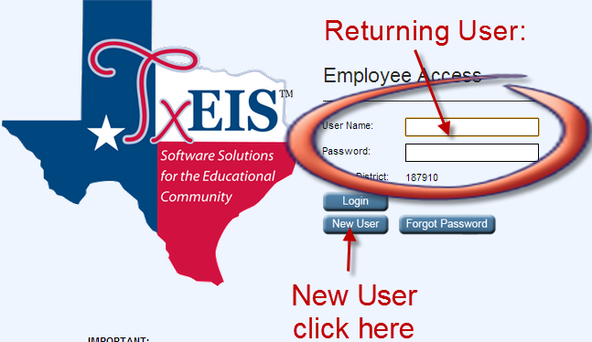

As a new user click the new user button and create an account using the directions below. If you have already created the account before you can simply enter the user name and password.

For assistance with any of this process please contact 936-646-1000

CREATING YOUR ACCOUNT:
After clicking on new user a page will open asking for identifying information
Enter your 6 digit employee ID. You will need to add the 000 to the beginning of your number.
Once you have filled in the information select Retrieve.
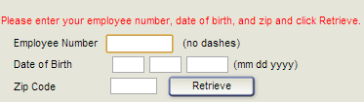
On the next screen enter a user name and a 8 digit password.
DO NOT CHANGE ANYTHING IN THE EMAIL SECTION
Create a hint question and answer and then click SAVE
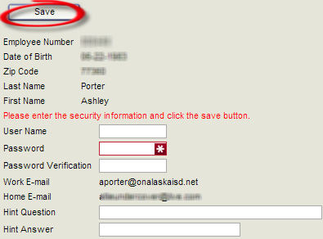
Once you have clicked SAVE you will see the following screen: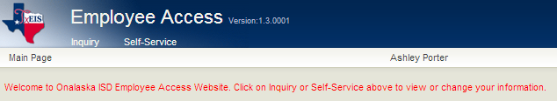
From here you can use inquiry to view your pay info or W2
Self Service will allow you to update your address, phone number, and banking information among other things.

