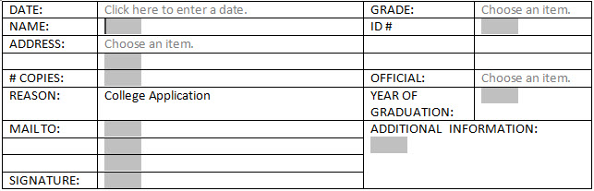

Please email this form to:

Wanda Ebert, Registrar webert@onalaskaisd.net
Robyn Thornton, Counselor rthornton@onalaskaisd.net

Or
Mail to:
Wanda Ebert
OJSH
PO BOX 2289
Onalaska, Texas 77360

936-646-1020

